ICS 103: Computer Programming in C
Spring Semester 2011-2012 (Term-112)
Lab #7: Functions with Input Parameters

Objectives:

- Learn how to write user defined functions.
- Learn void functions and functions that return result.
- Learn functions with input parameters.
- Learn the scope of variables.

Functions in C are block of statements that do a certain task. They are used to organize a program into smaller building blocks and make it easy to understand and follow its behavior.

Why functions?
- Modularity
- Maintainability
- Code reusability
- They facilitate information hiding (Consider the standard math functions we studied; we used them without knowing how they are implemented)

Note: In C, you cannot define a function inside another function.

Two types of functions will be covered in this lab: void functions with input arguments and functions with input arguments returning a single result:

1. void functions with arguments

- A function returning no value has return type void
- The value or values passed to a function when it is invoked (called) are called actual arguments.
- If no value is passed to a function when it is invoked, the argument list is empty.
- The syntax of a void function that has argument(s) is:

void functionName(parameterList){
declarations if any;
executable statements;
return; // optional
}

where parameterList is a comma separated list of variable declarations. Each variable is
called a formal argument to the function.

- If a function definition does not physically appear before the function calling it, it must be declared before any call to the function. That declaration is called the function prototype.
- The syntax of the prototype for a void function that has arguments is anyone of the following:

void functionName(parameterList); | void functionName(typeList);

- The call to a void function with arguments is a statement; it is not part of an expression. Its syntax is:
functionName(expressionList);

where expressionList is a comma separated list of expressions. Each such expression is
called an actual argument of the function.

Note:
- There must be a one-to-one correspondence between actual arguments and formal
arguments in terms of number and compatible type.
- A variable actual argument may or may not have the same name as the corresponding
formal argument (Note that even if the arguments have the same names, they are
different variables).
- The scope (domain where the variable is recognized) of a formal argument is its function block.
- The scope of a local variable (i.e., a variable declared within a function,) is from its point
of declaration to the end of the block.

Example 1-1

#include <stdio.h>
#include <stdlib.h>
void drawLine(int, char); // function prototype

int main(void){
int length;
char ch;

printf("Enter line length: ");
scanf("%d", &length);
fflush(stdin); //skips the enter key
printf("\nEnter the drawing character: ");
scanf("%c", &ch);
drawLine(length, ch); // function call
printf("\n");
drawLine(length*2 , ch); // function call
printf("\n");
system("PAUSE");
return 0;
}

void drawLine(int length, char ch){ // function definition
int k;
for(k = 1; k <= length; k++)
printf("%c", ch);
}

Example 1-2

//draws a rectangle using functions
#include <stdio.h>
#include <stdlib.h>
void draw_solid_line(int size); // function prototype
void draw_hollow_line(int size); // function prototype
void draw_rectangle(int len, int wide); // function prototype

int main(void) {
int length, width;

printf("Enter length and width of rectangle >");
scanf("%d%d", &length, &width);

draw_rectangle(length, width); // function call

system("pause");
return 0;
}
void draw_solid_line(int size) { // function definition
int i;
for (i=1; i<=size; i++)
printf("*");
printf("\n");
}
void draw_hollow_line(int size) { // function definition
int i;
printf("*");
for (i=1; i<= size-2; i++)
printf(" ");
printf("*\n");
}

void draw_rectangle(int len, int wide) { // function definition
int i;
draw_solid_line(wide); // function call
for (i=1; i<=len - 2; i++)
draw_hollow_line(wide); // function call
draw_solid_line(wide); // function call
}

2. functions with arguments returning a single value

- The syntax of a function with arguments and returning a single value is:

returnType functionName(parameterList){
declarations if any;
executable statements;
return expression;
}

Note:
- The expression in the return statement must have a type that is compatible with the
function's return type.
- It is possible for a function that has one or more selection structures to have more than one return statement; however only one such statement will be executed.

- The call to a function returning a single value is an expression; it can appear anywhere an expression is allowed.

Example 2-1

#include <stdio.h>
#include <stdlib.h>
double sumSquares(double, double); // function prototype
int main(void){
double w, z;

printf("Enter two numbers: ");
scanf("%lf%lf", &w, &z);

printf("\nw = %.2f , z = %.2f\n", w, z);
printf("\nThe sum of squares of 2*w + 2 and z is %.2f\n",
sumSquares(2*w + 2.0, z)); // function call

system("PAUSE");

return 0;
}

double sumSquares(double x, double y){ // function definition
return x * x + y * y;
}

Exampele 2-2
#include <stdio.h>
#include <stdlib.h>
int findMax(int, int); // function prototype

int main(void){
int num1, num2, maxValue;
printf("Enter two integers: ");
scanf("%d%d", &num1, &num2);
maxValue = findMax(num1, num2); //function call
printf("\nThe maximum of %d and %d is %d\n", num1, num2,
maxValue);

system("PAUSE");
return 0;
}

int findMax(int x, int y){ //function definition
int max;

if(x >= y)
max = x;
else
max = y;

return max;
}

Exampele 2-3

/* Computes the factorial of a number */
#include <stdio.h>
int factorial(int n); // function prototype

int main(void) {
int num, fact;
printf("Enter an integer between 0 and 7: ");
scanf("%d", &num);
if(num < 0) {
printf("Factorial not defined for negative numbers\n");
} else if (num <= 7) {
fact = factorial(num); //function call
printf("The factorial of %d is %d\n", num, fact);
} else
printf("Number out of range: %d\n", num);

system("pause");
return 0;
}

int factorial(int n){ //function definition
int i, product = 1;
for(i = n; i > 1; --i)
product *= i;

return product;
}

- Logical functions
In C, logical functions (functions that return true or false) are declared to be of int type: A function that returns 0, returns false, and a function that returns non-zero value, returns true.

Example 2-4

#include <stdio.h>
#include <stdlib.h>
int isEven(int); // function prototype

int main(void){
int num;
printf("Enter an integer: ");
scanf("%d", &num);
if(isEven(num)) // function call

printf("\n%d is even\n", num);
else
printf("\n%d is odd\n", num);

system("PAUSE");
return 0;
}

int isEven(int b){ // function definition

return b % 2 == 0;
}

Laboratory Tasks:

- Modify Example 1-2 so that the symbol to draw the rectangle, instead of being ‘*’, should be provided by the user.
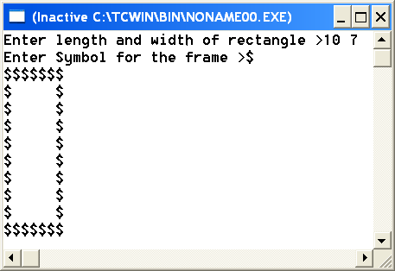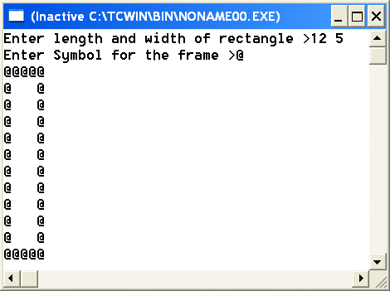
Note: In example 1-1, the symbol is provided by the user.

2. Write a void function divisors that receives an integer number and displays its divisors on the screen including 1 and itself. Write a main function to test your function.
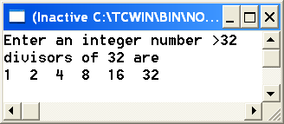

3. Modify the function divisors so that it returns an integer result. Now, the function will return (not print) the number of divisors excluding 1 and the number itself. Write a main function to test your function.
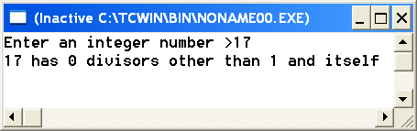
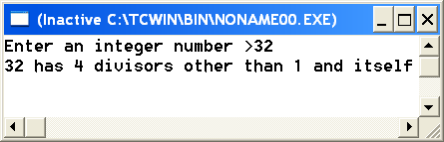
The 4 divisors of 32 are 2,4,8 and 16.

4. Write a logical function perfect_Square that receives a positive integer number and checks if it is a perfect square or not.
The function returns 1 if the received integer number is a perfect square. If not, it returns 0.
Note: perfect square numbers are 4, 9,16,25,36 etc….. A perfect square is an integer number whose square root is also an integer number.
Write a main function that makes use of the perfect_Square function to find and print all perfect squares between m1 and m2 inclusive, where m1 and m2 are end values of a range input by the user. Your program must display an appropriate message if there is no perfect square between m1 and m2 inclusive. The loop to look for perfect squares must be in the main function not in perfect_Square function.

